
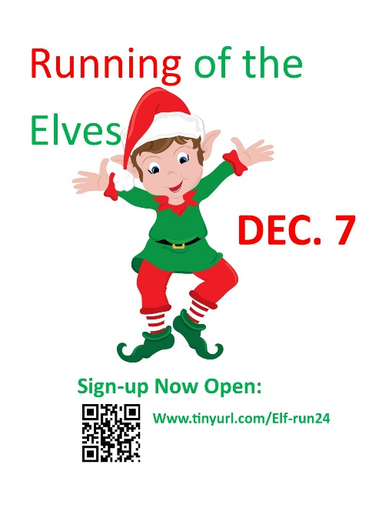Sponsorship Levels
Pixie Sponsor ($100)
- Company Logo and link on Running of the Elves Race site and registration page
- Opportunity to contribute flyers/other marketing item to swag bags
- Sponsor announcement on Race Day
- Inclusion of logo and Company info on one Huntley Rotary Facebook post
Gnome Sponsor ($250)
- ALL Pixie Sponsor benefits PLUS:
- Opportunity to have a table at the registration/post-race party (Gazebo)
- Inclusion of logo & link on all e-newsletters (distribution to approx.5,000)
- Company logo on race t-shirt (only available with commitment before 11/7/24)
- Company logo on race day banner
Leprechaun Sponsor ($500)
- ALL Gnome Sponsor benefits PLUS:
- Company logo on lawn sign along race course
- Inclusion of Company logo on Rotary Club website for 3 months
Buddy Elf Sponsor ($1,000)
- ALL Leprechaun Sponsor benefits PLUS
- Inclusion of logo on Rotary Club website for additional 3 months
- 100-word advertisement with image in post-race email to all participants
- Four complimentary race entries
Level selected: __________________________________
- Name ______________________________________________ (please print)
- Company _______________________________________________________
- Address ____________________________City __________ St___ Zip______
- Email _______________________________________ Phone __________
- Signature _________________________________________ Date _________
- Please return pledge, payment and high-resolution logo prior to November 7, to HuntleyRotary@yahoo.com or P O Box 323, Huntley, IL 60142

